How High-Impact Practices Impact the overall GPA

of Undergraduate College Students

Eric Shin

University of Washington Bothell

December 7th, 2020

Abstract

This paper explores one set of data of undergraduate students who attended UW Bothell from years 2011 to 2017 through one Tableau figure. Additionally, two published articles that report on results and findings from the effects of taking High-Impact Practices are explored as well. The data set that I am using contains important information because it shows the exit GPA of every undergraduate student who either participated or did not participate in High-Impact Practices. The category from the data source that was used as evidence for the Undergraduate Students who both participated and did not participate in High-Impact Practices was average exit GPA by the time they graduated. The selected subset of data that was used was data from undergraduate students who participated in High-Impact Practices compared to undergraduate students who did not participate in High-Impact Practices. In the first article, authors Brownell, Jayne E., Swaner, and Lynn E. (2009) suggested strong positive effects of participating in high-impact activities as measured by the National Survey of Student Engagement (NSSE) based off of first-year students and seniors who participated in learning communities, service learning, study abroad, student-faculty research, and senior culminating experiences. In the second article, authors Cindy A. Kilgo, Jessica K. Ezell , and Ernest T. Pascarella (2015) suggested high-impact practices as pathways to student success. This paper examines mainly the Tableau figure from the set of data which is used as the main evidence for the argument. The two additional articles are used as backup evidence for the argument.

*Keywords*: Average GPA, High-Impact Practices, Participation, Undergraduates, Success

How High-Impact Practices Impact the overall GPA

of Undergraduate College Students

At the University of Washington Bothell, the overall GPA among undergraduate students has shown significant highs and lows. However, studies have shown that with the help of High-Impact Practices, the overall GPAs have actually been proven to increase as well as show consistent positive trends in overall GPA among these undergraduate students at UW Bothell. According to these studies outside of UW Bothell specifically, first-year students and seniors who participated in learning communities, service learning, study abroad, student-faculty research, and senior culminating experiences reported greater gains in learning and personal development. These gains included "deep approaches" to learning, which encompass integrating ideas and diverse perspectives, discussing ideas with faculty and peers outside of class, analyzing and synthesizing ideas, applying theories, judging the value of information as well as one's own views, and trying to understand others' perspectives (2009). Adding on from these studies outside of UW Bothell, deep approaches to learning are important because students who use these approaches tend to earn higher grades and retain, integrate, and transfer information at higher rates. From one instance, according to studies by the AAC&U (Association of American Colleges and Universities), first-year seminars and experiences, common intellectual experiences, learning communities, writing-intensive courses, collaborative assignments, and undergraduate research are some great examples that are suggested to lead to greater engagement and retention among undergraduate students (2015). So, participating and engaging in these High-Impact Practices could ultimately help students succeed throughout college, while giving undergraduate students a good start to their college experience and beyond when they end up graduating. The main research question is, “How much do High-Impact Practices affect the GPA of undergraduate students at UW Bothell?” As stated earlier, there have been numerous positive correlations of taking High-Impact Practices such as learning gains, higher gpa, ability to take in and analyze information better, etc. It can be believed that this positive correlation from experiences with High-Impact Practices will continue to decrease any of the problems, gaps, and inconsistent trends in GPA among undergraduate students at UW Bothell. On the other hand, it can be believed that more participation in High-Impact Practices will ultimately increase GPA as well as the ability to keep a higher GPA among undergraduate students at UW Bothell.

**Methods and Materials**

According to the UW Bothell Excel Sheet that contains Student Data on Exit GPA among undergraduate students, the data was collected from the years 2011 to 2017. The source of the data comes from the University of Washington Bothell itself with the data collected from each student who attended UW Bothell. The selected subset of data that is being used is data from undergraduate students who participated in High-Impact Practices compared to undergraduate students who did not participate in High-Impact Practices. In the data set, the section that is being used is every undergraduate student who both participated and did not participate in High-Impact Practices, which is roughly over 20,000 students. The section and column that these undergraduates are being analyzed from is the Exit GPA on a 0.1 to 4.0 scale, removing the non-zeros from the data set. From the looks of the data source, there is no missing information or data for what should be presented. However, since this data set shows data from past years, the only thing that should have been included in the data set is data from more recent years. The section and column that is being used represents a nominal scale since there are different sections and categories to analyze from. The data set that is being used contains important information because it shows the exit GPA of every undergraduate student who either participated or did not participate in High-Impact Practices. The category from the data source that I am using is reliable because it correlates with my research question as a main source of evidence to back up the argument.

**Results: Visualization**

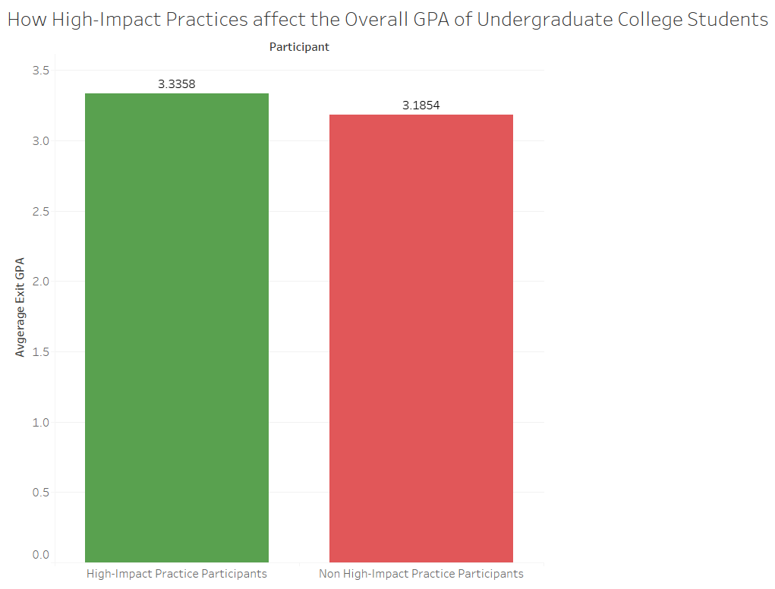

Figure 1 shows the difference between the Average Exit GPA of Undergraduate Students who participated in High-Impact Practices and Undergraduate Students who did not participate in High-Impact Practices

Participation in High-Impact Practices may potentially increase the overall GPA among undergraduate students in college. The data that is being used as evidence is the Exit GPA among Every Undergraduate Student who both participated and did not participate in High-Impact Practices at the University of Washington Bothell on a 0.1 to 4.0 GPA Scale (From Years 2011 to 2017). According to the numbers in Figure 1, the undergraduate students who participated in High-Impact Practices ended up finishing college with an Average Exit GPA of 3.34. In comparison, the undergraduate students who participated in High-Impact Practices ended up finishing college with an Average Exit GPA of 3.19. From these numbers, it can be clearly seen that the Average GPA of undergraduate students who participated in High-Impact Practices is slightly higher than the Average GPA of undergraduate students who did not participate in High-Impact Practices. The results of this data can infer that the participation in High-Impact Practices do indeed have a positive affect and correlation on the overall GPA of undergraduate students. This figure clearly backs up the claim of High-Impact Practices positively affecting the overall GPA of undergraduate students because there is a slight margin in overall GPA among the two groups with one group noticeably being higher than the other. The difference in overall Exit GPA among the two groups is nearly 0.15. Though the marginal difference may not be that significant, the data proves that High-Impact Practices can indeed help increase overall GPA to somewhat of a good extent.

**Discussion**

With the intention of coming to a better understanding on how High-Impact Practices affect undergraduate students, we explored the positive correlation between participation in High-Impact Practices and overall Exit GPA across every department and program offered at the University of Washington Bothell. From these findings and positive correlations, High-Impact Practices should be taken into consideration or even as a strong recommendation for every college student attending the University of Washington Bothell, not just the undergraduate students. At UW Bothell, the faculty itself should start raising awareness about High-Impact Practices by educating and informing students about the contents and benefits of a High-Impact Practice. Additionally, students should be educated and informed about the different programs that these High-Impact Practices offer, in order to meet their individual needs for their specific classes and majors. One main limitation in this research was the lack of recency numbers. The data set used in the research were numbers from the years 2011 to 2017. Though the outcome of the Average Exit GPAs may still be pretty accurate, the numbers could be even more accurate and could potentially alter the average Exit GPAs to a certain extent by adding the more recent years such as years 2018, 2019, and 2020. Both qualitative and quantitative approaches to this research can be further advanced with these extra data factors. Through future research and deeper analysis of the data at hand is needed, as well as other needed additional data, there is potential to better understand the role that High-Impact Practices play on students by not only analyzing just undergraduate students. While High-Impact Practices can be seen as a beneficial GPA boost to undergraduate students, this is not certain with other grade levels, career levels, and entries such as graduate level students, baccalaureate level students, specific first-year first term students, as well as transfer students. Adding on from the additional years needed to make the data set more accurate, it is very likely that the number of students attending the University of Washington Bothell will fluctuate every year due to students transferring into the school as well as students transferring out of the school to attend a different college. Furthermore, a clear and definite sample size of students who attend the University of Washington Bothell will most likely make the data as accurate as possible along with the other previously mentioned factors playing a role in this research.

**Works Cited**

Brownell, J. E., & Swaner, L. E. (2009), “High-impact practices: Applying the learning

outcomes literature to the development of successful campus programs.” Peer Review, 11(2), 26-30. Retrieved from <https://search.proquest.com/docview/216602278?accountid=14784>

Kilgo, C., Sheets, J., & Pascarella, E. (2015), “The link between high-impact practices and

student learning: Some longitudinal evidence. Higher Education.” 69(4), 509-525. Retrieved October 27, 2020, from <http://www.jstor.org/stable/43648809>

Taylor, A., Yochim, L., & Raykov, M. (2019), “Service-Learning and First-Generation

University Students: A Conceptual Exploration of the Literature.” Journal of Experiential Education, 42(4), 349–363. <https://doi-org.offcampus.lib.washington.edu/10.1177/1053825919863452>

(Links to an external site.)

University of Washington Bothell. (2011-2017). Student Data Excel Sheet.

Retrieved from studentdata.xlsx

**Appendix A**

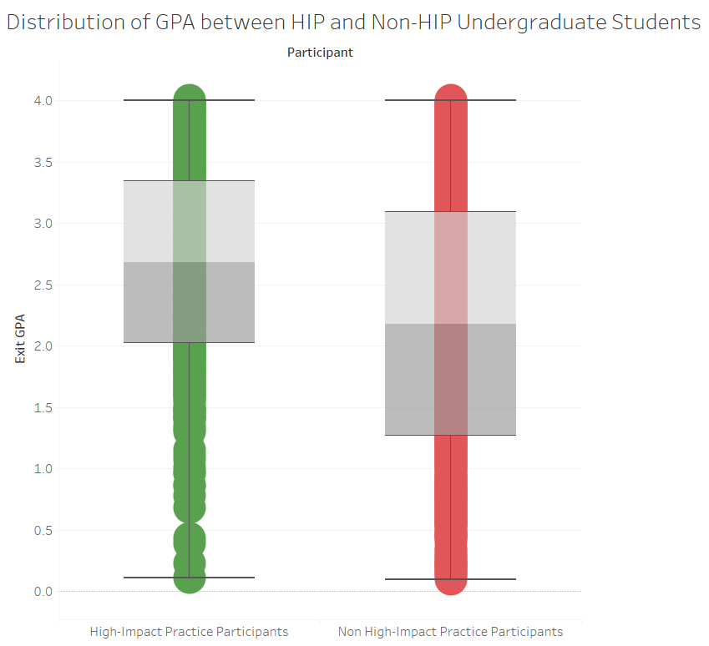

**Appendix B**

